**IMS 222 (Introduction to Interaction Design and Development)**

**Hands-On #5 (Responsive Web Design)**

1. [**Viewport**](https://miamioh.edu/)**: Add Viewport to responsive.html head section**

**<meta name="viewport" content="width=device-width">**

**\***[**initial-scale=1**](https://css-tricks.com/probably-use-initial-scale1/)

1. 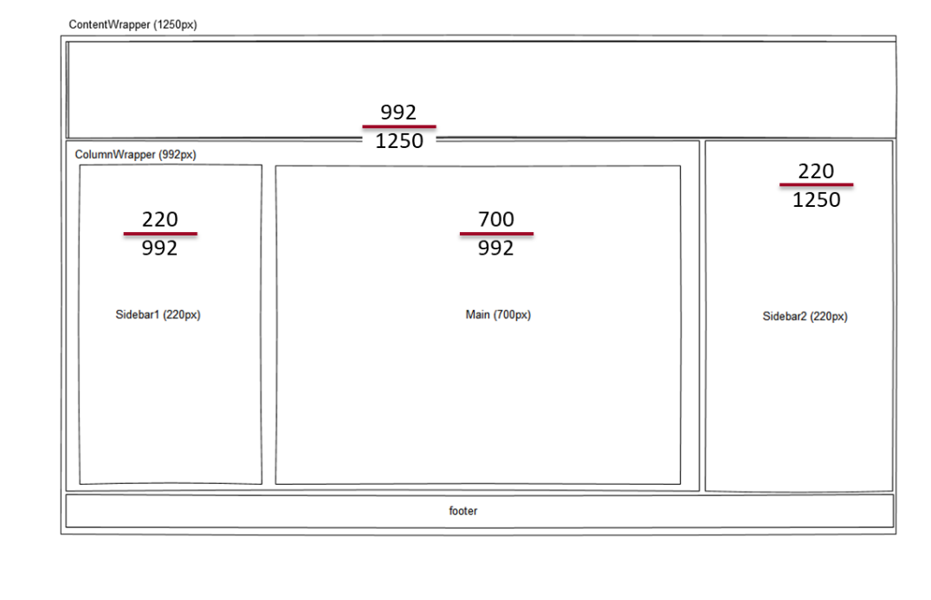**Flexible Grid: Go to styles.css and change px-based width and %-based width and see the changes from your browser.**

**\* {**

[**box-sizing**](https://developer.mozilla.org/en-US/docs/Web/CSS/box-sizing)**: border-box;**

**}**

.columnWrapper {

float: left;

**width: 80%;**

}

.sidebar2 {

float: right;

**width: 20%;**

padding: 0 10px 0 20px;

}

.sidebar1 {

float: left;

**width: 25%;**

padding: 0 20px 0 10px;

}

.main {

float: right;

**width: 75%;**

padding: 0 10px;

border-left: 1px dashed red;

border-right: 1px solid blue;

}

1. **Fluid Images:** 
   1. **Go to styles.css and add the following code.**

**img {**

**max-width: 100%;**

**}**

* 1. **Go to responsive.html and remove width attributes from all <img> elements and see the changes from your browser.**

1. **Media Queries: Add the following code to styles.css and see the changes from your browser.**

/* tablet size */

@media (min-width: 768px) and (max-width:1024px) {

.sidebar2 {

width: auto;

clear: both;

border-top: 2px solid black;

padding-top: 10px;

}

.columnWrapper {width: auto;}

.main {border-right: none;}

}

/* mobile phone size */

@media (max-width: 767px) {

.columnWrapper, .main, .sidebar1, .sidebar2 {

float: none;

width: auto;

}

.main {border: none; }

.sidebar1, .sidebar2 {

border-top: 2px solid black;

margin-top: 25px;

padding-top: 10px;

}

header h1 { font-size: 1.5em; }

.main h2, aside h2 {font-size: 1.5em;}

nav {text-align: center;}

nav li {

float: none;

display: inline-block;

}

nav a { border: none; }

}